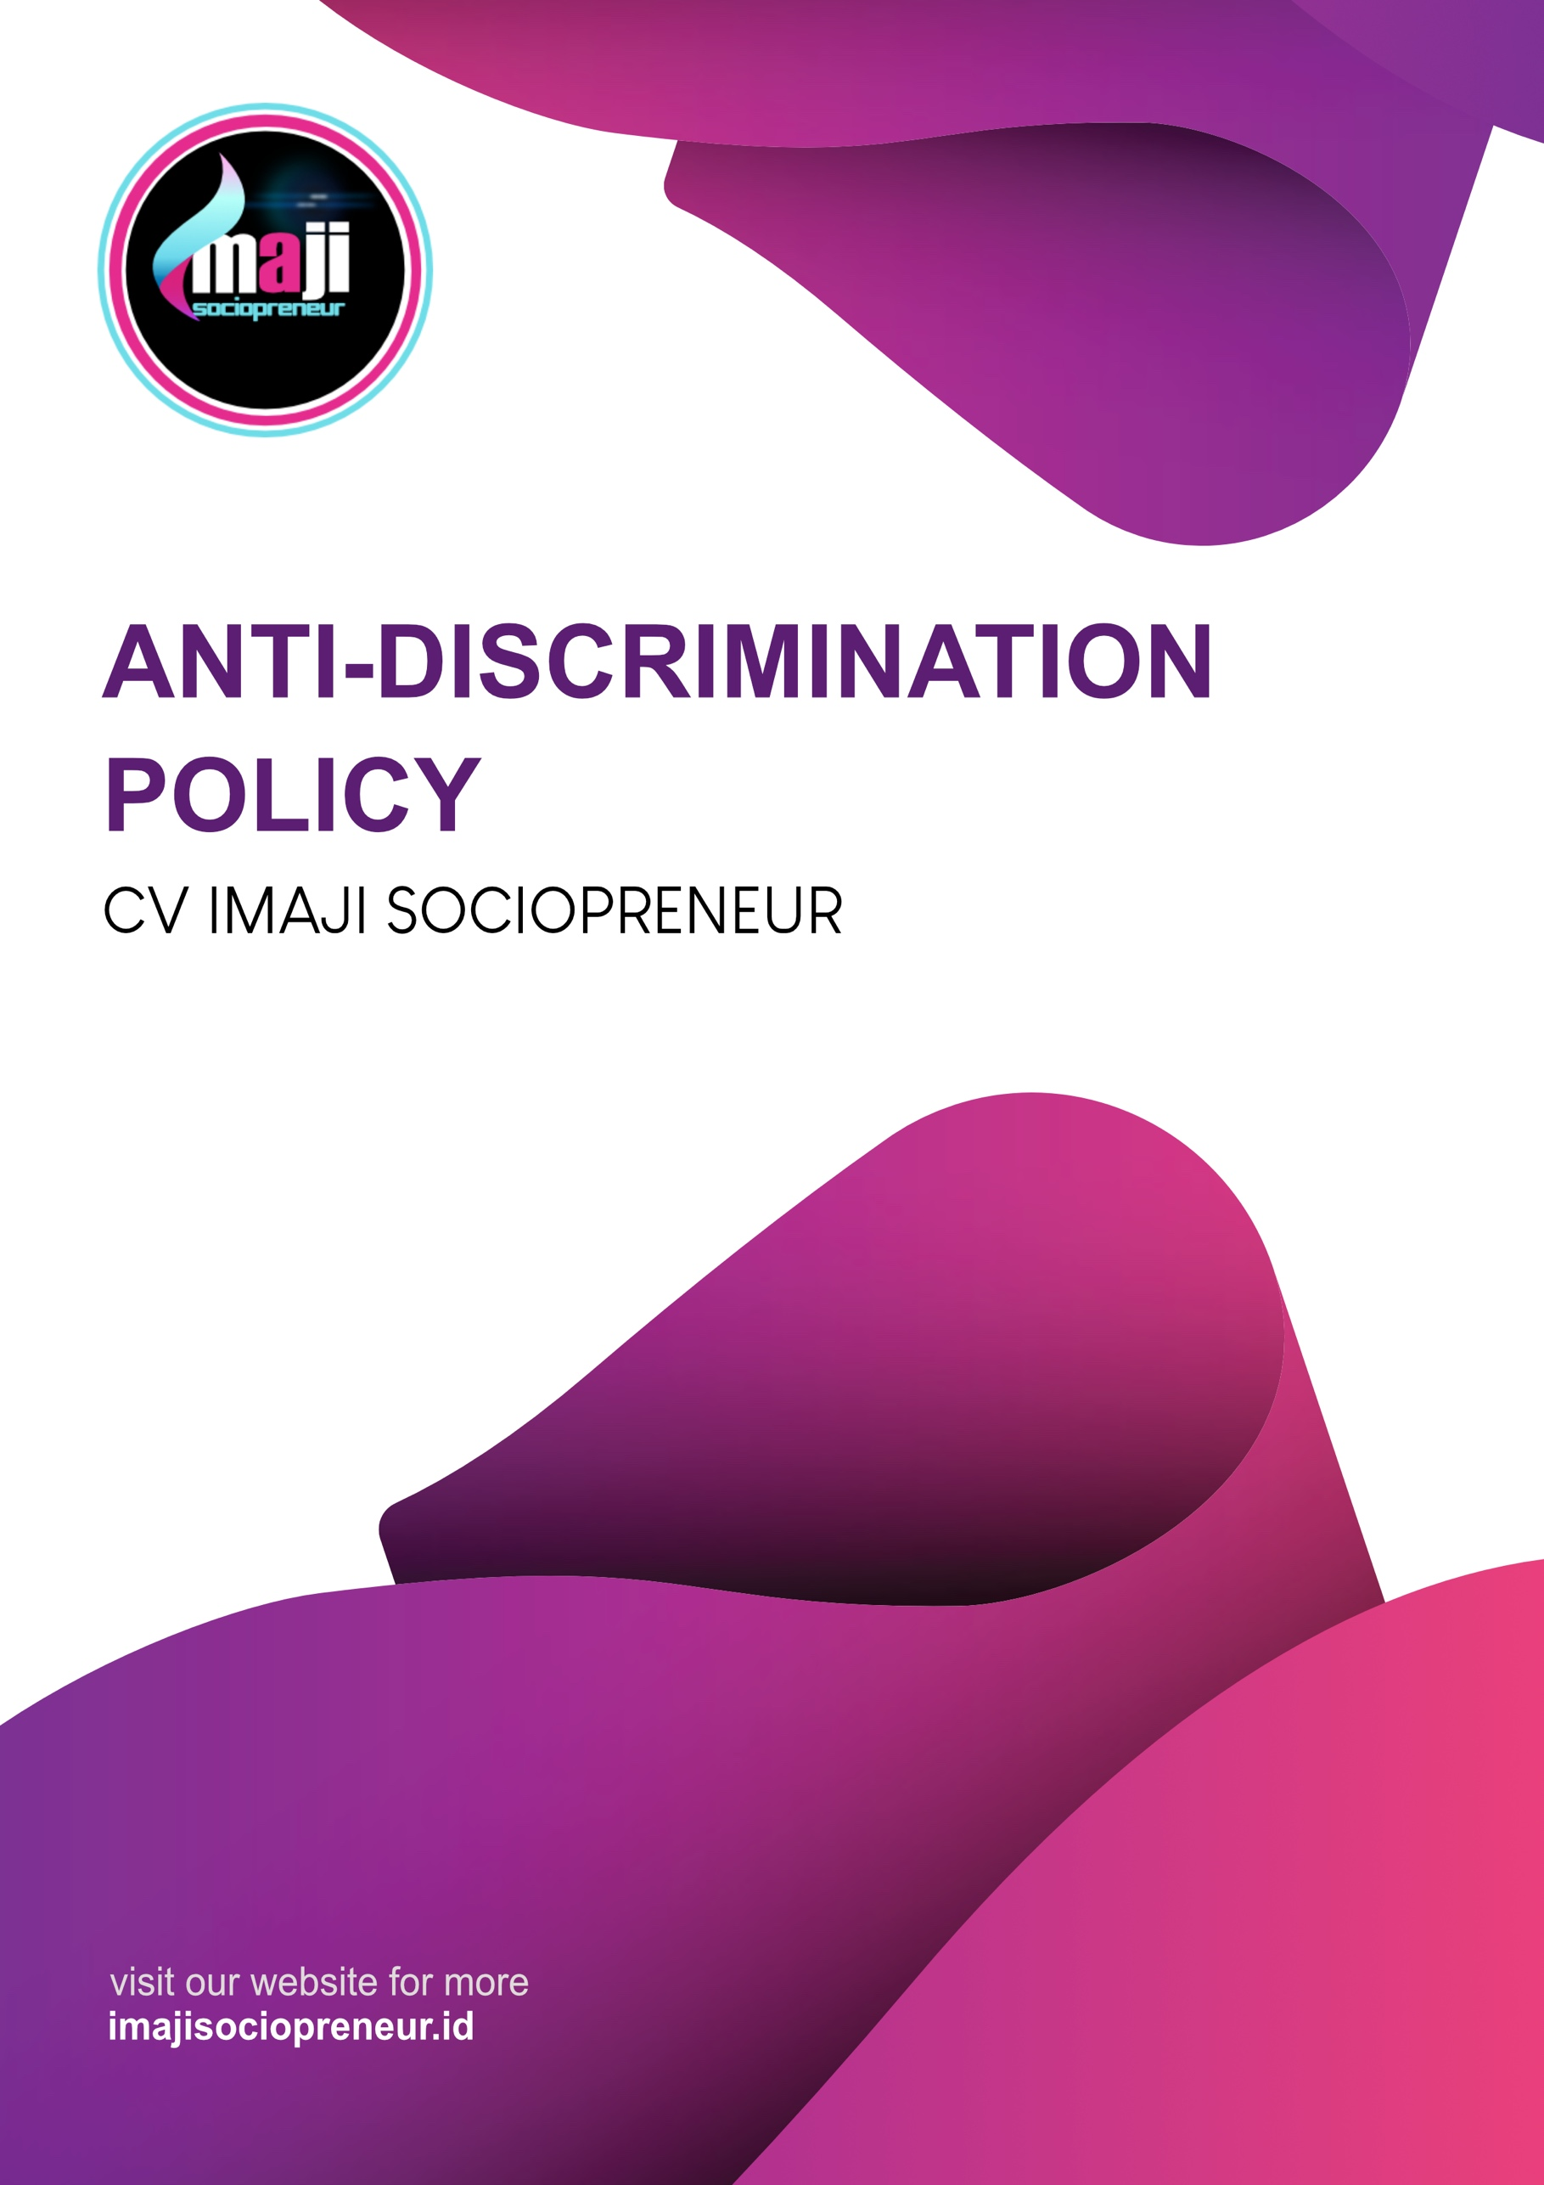
INTRODUCTION

Racial and ethnic discrimination is any form of distinction, exclusion, restriction or selection based on race and ethnicity, which results in the revocation or reduction of the recognition, acquisition or implementation of human rights and basic freedoms in an equality in the civil, political, economic, social fields, and culture. The global community is working together to eliminate discrimination because this action is a violation of human rights. The impact of discrimination can reduce, distort, erase the recognition, implementation, or use of human rights and basic human freedoms in life both individually and collectively. The following is an explanation of discrimination, especially discrimination in jobs and positions.
Article 1 paragraph (3) of Republic of Indonesia’s Law Number 39 of 1999 concerning Human Rights provides an explanation of discrimination as any restriction, harassment or exclusion that is directly or indirectly based on human differentiation on the basis of religion, ethnicity, race, ethnicity, group, class , social status, economic status, gender, language, political beliefs, which result in reduction, deviation or elimination of the recognition, implementation or use of human rights and basic freedoms in life both individually and collectively in the political, economic, legal, social, cultural fields , and other aspects of life.
On June 25, 1958, the International Labor Organization (ILO/International Labor Office), adopted Convention No. 111 concerning Discrimination in Employment and Occupation. In Indonesia, this Convention has been declared effective since May 7, 1999, through Law Number 21 of 1999 concerning Ratification of the ILO Convention on Discrimination in Employment and Occupation. The Convention emphasizes that discrimination in employment and occupation refers to any difference, exclusion or choice based on race, color, sex, religion, political opinion, nationality or social origin, which results in the loss or reduction of equality of opportunity or treatment in employment or position.

Forms of discrimination in jobs and positions include
- Discrimination against freedom of association and protection of the right to participate in an organization.
- Discrimination against equality of treatment, opportunity, and arrangement of equal working conditions in the workplace.
- Discrimination in remuneration for the same type of work.
- Discrimination to obtain training.
- Discrimination to obtain certain jobs and positions, as well as terms and conditions of work in recruitment, selection and placement.
What is discrimination at work?
Discrimination occurs when someone is treated poorly because of certain attributes. Discrimination can involve some or all of the following:
- Behavior that could be considered harassing, coercive or disruptive, including sexual harassment
- Make a 'joke' that offends religion or beliefs, sexual orientation, traditions, ethnic background, skin color, gender, and other workers' disabilities
- Expressing negative stereotypes about certain groups, for example, "Married women cannot work."
- Judging someone on their political or religious beliefs rather than job performance.
- Using a selection process based on irrelevant attributes such as religion or beliefs, sexual orientation, and traditions rather than knowledge, skills and achievements.
SCOPE

This policy applies to all employees, central management, café crew, daily workers and freelancers. In this Policy, "workplace" includes office facilities, cafes, Integrated Waste Processing Sites (TPST), recycle hubs, and all places visited or attended by employees while carrying out their work and duties or representing the Company, including at work-related social events, client places and entertainment events, modes of transportation provided by CV. Imaji Sociopreneur for work-related travel, and other locations where company activities take place, or which could reasonably be considered an extension of the workplace.
This policy applies to physical conduct and actions and all forms of communication including, but not limited to in-person communications, telephone conversations, email, social media apps and sites, SMS and other types of electronic communications.
PURPOSE OF POLICY

The purpose of this Anti-discrimination Policy is to ensure that all:
- Employees or prospective employees of CV. Imaji Sociopreneurs do not experience unfair discrimination in the workplace.
- Individuals and groups in the CV. Imaji Sociopreneur work in an environment where all decisions are free from discrimination and have equal opportunities based on relevant abilities and achievements.
- Employees are encouraged to take positive action to promote equal opportunity throughout the organization.
- Employment measures, such as compensation, benefits, layoffs, and social and recreational programs are carried out on a non-discriminatory basis.
- Application of labor law to be actively implemented in the company.
PARAMETER OF DISCRIMINATION

CV. Imaji Sociopreneur and its employees strive to create a workplace that is free from discrimination in their employment practices towards prospective or current employees, and will not discriminate in relation to:
1. Age or other circumstances
2. Skin color
3. Cultural or social beliefs such as religion
4. Educational background
5. Race, ethnicity or nationality
6. Spiritual beliefs, traditions or customs
7. Political opinion
8. Gender identity and expression
9. Marital status
10. Pregnancy or assessing the potential impact of pregnancy on breastfeeding decisions
11. Sexual orientation
12. Health or disability or physical impairment
13. Medical records
14. HIV status
15. Family responsibilities

POLICY

General Prohibition
The company strictly prohibits all forms of discrimination, such as discrimination based on the characteristics mentioned in the previous points. All employees are responsible for reporting discriminatory behavior by other employees. The company will take action to investigate and handle cases that are considered discrimination in a timely manner and in accordance with the applicable laws and regulations in Indonesia. Cases of discrimination that are proven to have occurred will result in corrective actions up to termination of employment for the perpetrators taking into account all circumstances as well as applicable laws and regulations.
Report Suspected Policy Violations
Every employee must comply with this Policy and be responsible for reporting suspected discrimination to the Company so that the situation at issue can be resolved. The company takes all complaints of discrimination and harassment seriously.
Anyone who believes he or she has experienced discrimination at work or who witnesses or knows about acts that could be considered discriminatory must immediately report these actions to the anti-discrimination committee of CV. Imaji Sociopreneur.

PROCESS AND PROCEDURES
COMPLAINTS FOR ACTS OF DISCRIMINATION

How to make a complaint
Employees wishing to file a complaint or suspicion of discrimination can consult and submit it to the Anti-Discrimination Committee. Reporting of complaints can be submitted through the following channels:
1. Via the internet to imajisociopreneur.id
2. Via email to humas@imajisociopreneur.id
3. By telephone +62 331 5451066
4. In written form to:
Department of Public Relations – Anti-Discrimination Committee
Jalan Tawangmangu Gg. 06 Number 10 Tegalgede Sumbersari Jember, East Java Code 68124
The Committee will make every effort to finalize the report and take corrective action if discrimination is found. Complaint reports must include the following information:
1. Full Name
2. Organization Name (if any)
3. Position
4. Address
5. Phone Number
6. Detailed description of forms of discrimination
7. Evidence to support an act of discrimination.
Contact details are required to request further clarification regarding a report of a discrimination complaint.
Anti-Discrimination Committee
Member of Anti-Discrimination Committee :
No. | Name | Position | Part of Committee
1. | Moch Musta’Anul Khusni | President Director | Head of Committee
2. | Rohman Abadi | Environment Director | Member
3. | Mokhamad Asif | Research & Technology Director | Member
4. | Fuad Adityawan | Public Relation Manager | Member
5. | Difta Ayu Saputri | Education Manager | Member
6. | Galuh Putri Manggali | Finance Manager | Member

ACTION AFTER RECEIVING A COMPLAINT

Investigation
All reports of alleged discrimination will be investigated objectively and expeditiously. All employees are expected to cooperate in any investigations conducted under this Policy. Refusing to cooperate with an investigation may result in disciplinary action. Furthermore, given the seriousness of the act of discrimination, making a false report or complaint with malicious intent will result in disciplinary action.

Confidentiality
The company will keep all reports of allegations of discrimination confidential to the extent reasonably practicable while still fulfilling its obligations to investigate and resolve any discriminatory allegations. The committee needs to discuss the alleged act with people who know and are the target of the report or complaint.
Collection of personal data is required during the investigation of suspected discriminatory act as a reference to determine whether the reports received by the committee are valid or not. The company will comply with all applicable laws and regulations related to the protection of personal data. The personal data of persons involved in an investigation will be processed by the committee solely for the purpose of investigating the reported behavior, and only communicated to those who need to know about the reported behavior and to the necessary public, administrative or judicial authorities.
Corrective action will be given to proven violators through the findings. Corrective actions that may be taken include, but are not limited to, training, coaching, verbal or written warnings, suspension, reduced leeway, adjustments, and termination of employment. The company will make every effort to notify people who report violations of this Policy about the results of investigations whenever possible while maintaining confidentiality and privacy issues related to personal actions.
Mediation
CV. Imaji Sociopreneur supports resolution through mediation as long as it is consistent with the duties, obligations and needs of the company. Mediation can be carried out voluntarily if both parties agree to participate and have found an agreement in resolving existing problems.
Timeline
CV. Imaji Sociopreneur will investigate all complaints promptly and will seek resolution and prevention of discriminatory acts and practices. Settlement of complaints of discriminatory acts is sought to be completed within 35 working days from the date of filing the complaint.
Result & Resolution
CV. Imaji Sociopreneur will act quickly to ensure that discriminatory practices are stopped as soon as possible and can improve the situation in several ways. If the investigation determines that discrimination has occurred or the matter has been successfully resolved, then the results will refer to corrective action, including transferring the complainant to another department, changing the reportee's job assignments, or a letter of apology. Actions taken to remedy a discriminatory situation must not have a negative impact on the complainant. The primary obligation of employers is to ensure that discrimination ends and restore workplace as a harmonious environment.



Law of the Republic of Indonesia Number 40 of 2008 article 1 paragraph (1) Concerning the Elimination of Racial and Ethnic Discrimination

