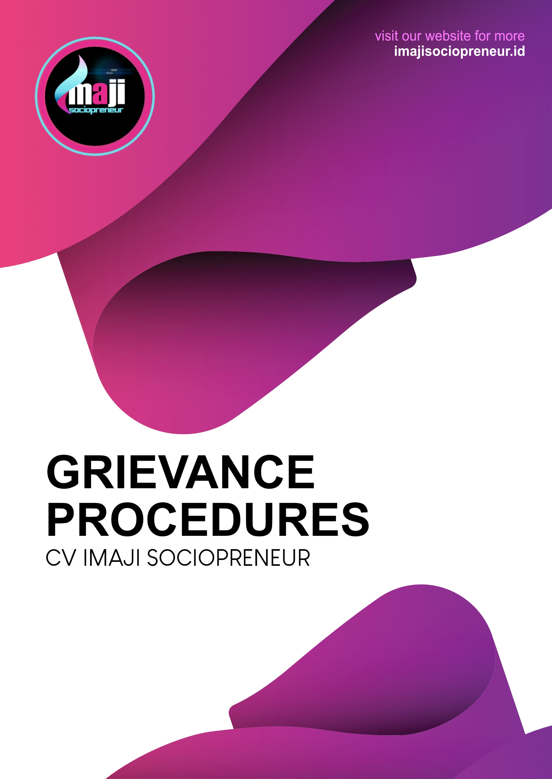
GRIEVANCE PROCEDURES
CV IMAJI SOCIOPRENEUR

Imaji realizes that internal and external parties Imaji Sociopreneur need a place to submit official complaints about practices within the company and outside the company in carrying out activities or projects. This policy was created to ensure that all internal and external parties are always heard and treated the same. This policy applies to all internal and external stakeholders, including individuals, employees, contractors, suppliers, social groups and civil society organizations. “Grievance” is defined as complaint, issue, and/or objection concerning policies and program implementation undertaken by Imaji Sociopreneur to the internal and external parties. Imaji’s Grievance Raising and Handling Mechanism encourages the participation of internal and external stakeholders, related to complaints, problems, and/or objections related to policies made by Imaji via email with the subject:

[GRIEVANCE] to:
Email: humas@imajisociopreneur.id

In receiving grievance reports, Imaji Sociopreneur is committed to maintain and protect the confidentiality of the grievance raiser's identity from all forms of threats and harassment. The results of the investigation of grievance as well as recommendations by the Public Relations Department are submitted to the Board of Directors for further decision on the grievance. Further handling of reported grievance is carried out in accordance with company regulations and applicable laws in Indonesia.

BACKGROUND

Imaji's Policy on Grievance Procedure is committed to providing a transparent and open process for stakeholders to submit grievances. To ensure sustainable long-term growth, Imaji Sociopreneur realizes that various stakeholders play an integral role in the company's sustainability strategy and related policies. Implementing an effective grievance mechanism is in line with the Commitment to Human Rights and the International Convention on the Elimination of All Forms of Racial Discrimination. As part of its focus to develop a multi-stakeholder approach, Imaji is committed to prepare a Grievance Handling Procedure so that stakeholders can properly submit grievances to Imaji.
All grievances recorded in the Grievance Handling Procedure will be dealt with in a timely manner, and all investigations and findings will be reported in a transparent manner. Given our commitment to the best practices, Imaji will conduct annual reviews in order to continuously improve this procedure and is committed to prevent grievances and negative impacts from our business activities in the future.

PURPOSE

The Grievance Handling Procedure serves to review, resolve, and monitor the results of any grievances raised by internal and external parties related to Imaji’s activities or projects. The objective is to provide a transparent, open and monitorable process for dealing with grievances. Imaji recognizes and appreciates that feedback and input can help increase transparency and improve the implementation of company activities. The grievance process was developed with the aim of achieving long-term transformation of business activities.
The objectives of handling complaints and complaints from stakeholders or third parties are as follows:
- As a reference/guideline for the company in receiving, responding, handling and resolving public complaints and grievances.
- Organize the handling of internal and external grievances so that it can be resolved in a timely manner and precisely in carrying out effective and efficient corrective and preventive actions.

SCOPE

Grievance is defined as complaint, issue, and/or objection concerning policies and program implementation undertaken by Imaji Sociopreneur to the internal and external parties. This grievance process is implemented by Imaji to handle grievance raised by the internal or external parties including individuals, employees, contractors, suppliers, social groups, and civil society organizations related to policies and activities or projects implemented by Imaji Sociopreneur.
PROCESS FLOW
GRIEVANCE PROCEDURES

a. Complaints can be submitted through one of the following channels:
1. Via the internet to imajisociopreneur.id
2. Via email to humas@imajisociopreneur.id
3. By telephone +62 331 5451066
4. In written form to:
Public Relations Department
Jalan Tawangmangu Gg. 06 Number 10 Tegalgede Sumbersari
Jember, East Java
Code 68124
Imaji will make every effort to provide information in a manner and form that is easily understood by the Grievance Raiser and relevant stakeholders, use of alternative communication techniques or assistive devices for those with hearing or visual impairments, or take other steps necessary to effectively facilitate stakeholders in communicating and submitting grievances.

b. Grievances must include the following information:
1. Full Name
2. Organization Name (if any)
3. Position
4. Address
5. Phone Number
6. Detailed description of the grievance
7. Evidence to support the grievance
Contact details are required to request further clarification regarding a complaint.

REFERENCE

This Grievance Process was developed as part of our Policy, July 2023 and is based on the following guidelines:
a. Imaji Sociopreneur’s Commitment to Human Rights
b. Anti-discrimination policy of CV Imaji Sociopreneur
c. CAO guidelines for designing and implementing a grievance mechanism
d. International Convention on the Elimination of All Forms of Discrimination

GENERAL TERM

- The company is Imaji Sociopreneur.
- Grievance Raisers are individuals or groups or agencies that submit grievance/complaints.
- Grievance is complaint, issue, and/or objection concerning policies and program implementation undertaken by Imaji Sociopreneur to the internal and external parties.
- Grievance procedure is a series of efforts, actions, or activities to manage grievance effectively and efficiently to achieve the common goals with maximum results.

TASK AND RESPONSIBILITY

- The Public Relations Department will endeavor to resolve and handle complaints with the relevant Departments.
- Depending on the type of grievance identified, consultations with other departments in the Company may be carried out together with the grievance raisers.
- The Legal Department should be engaged if there is any possibility of the grievance developing into a legal issue.
GRIEVANCE PROCEDURE FLOWCHART

